Activity 1

Aim: Create an Angular application which can create Captcha.

Learning outcome: Able to develop the real time scenarios based on Node JS applications.

Duration: 5 hour

List of Hardware/Software requirements:

1. Node.js and npm

2. Angular CLI

3. IDE (e.g. Visual Studio Code) Code/Program/Procedure (with comments):

Step 1. Create the Angular application

-> ng new angular-recaptcha-v2-main

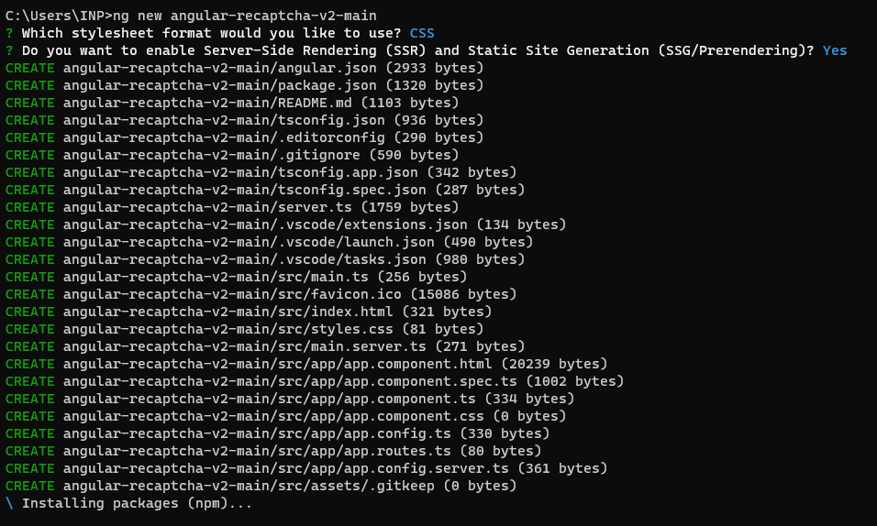

Step 2. Configure the siteKey variable with the Google reCAPTCHA

Create and configure the account on the google reCAPTCH

* Let’s create the account. Access the site <https://www.google.com/recaptcha/> and click on the button v3 Admin Console.

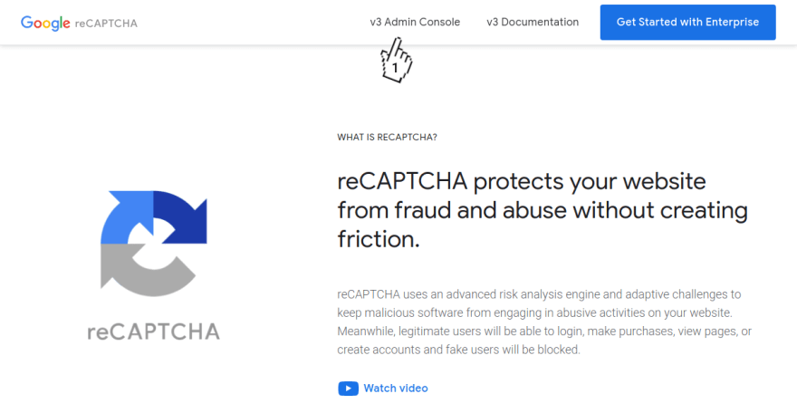

Fill in the field Label, click on the option reCAPTCHA v2, Fill in the field Domains, click on the checkbox Accept the reCAPTCHA Terms of Service and click on the button Submit

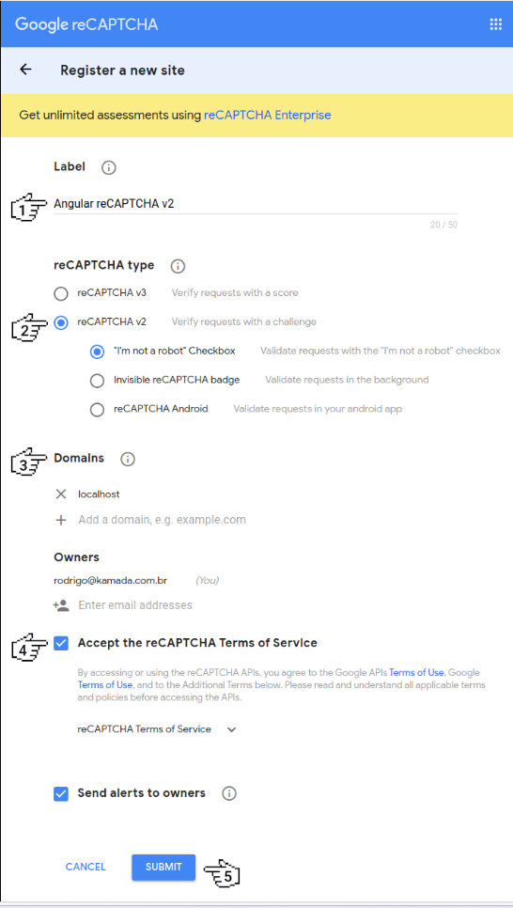

Click on the button copy site key to copy the key

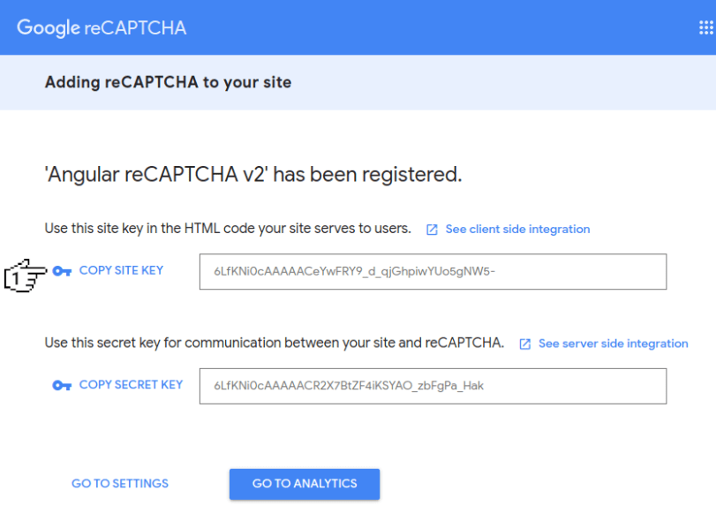

Step 3. Configure the siteKey variable with the Google reCAPTCHA key in the src/environments/environment.ts and src/environments/environment.prod.ts files as below

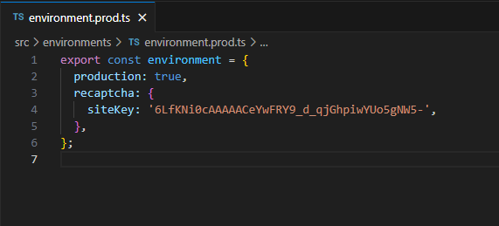

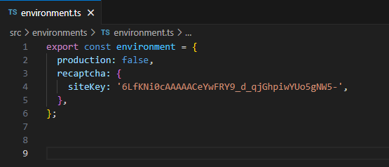

Step 4. Install the ng-recaptcha library

* npm install ng-recaptcha

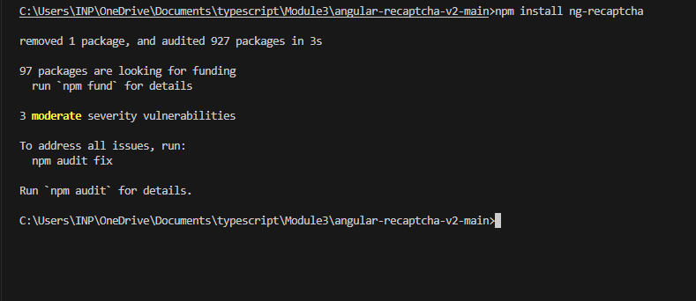

Step 5. Import the FormsModule, RecaptchaFormsModule, RecaptchaModule modules. Configure the Google reCAPTCHA key. Change the app.module.ts file and add the lines as below.

* app.module.ts

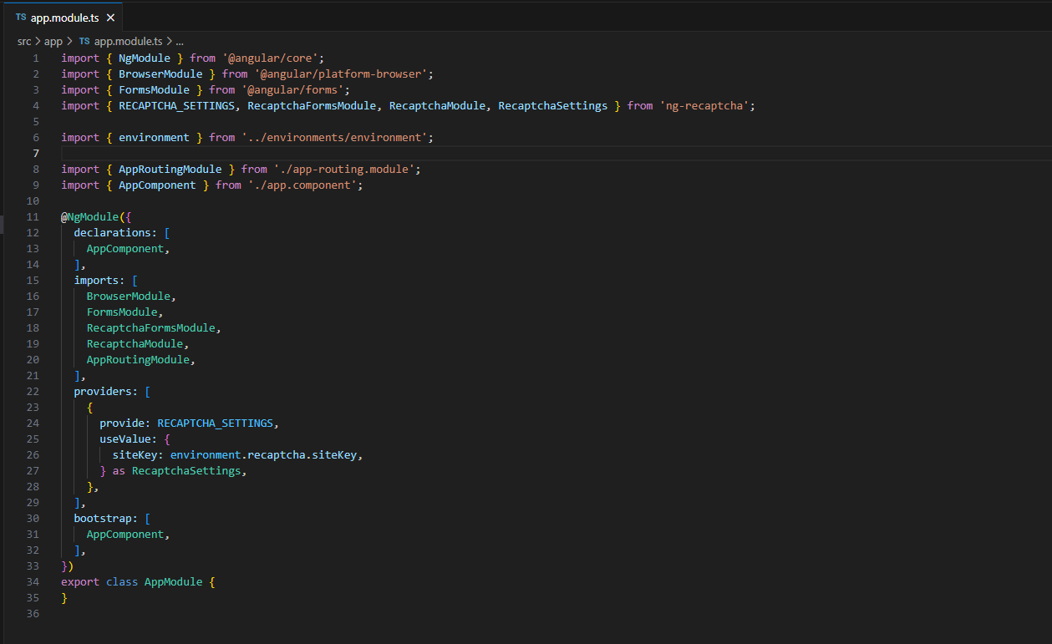

Step 6. Remove the contents of the AppComponent class from the src/app/app.component.ts file. Import the NgForm component and create the send method as below.

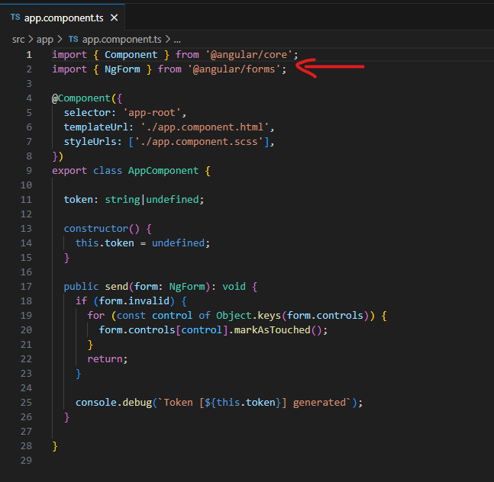

Step 7. Remove the contents of the src/app/app.component.html file. Add the re-captcha component as below.

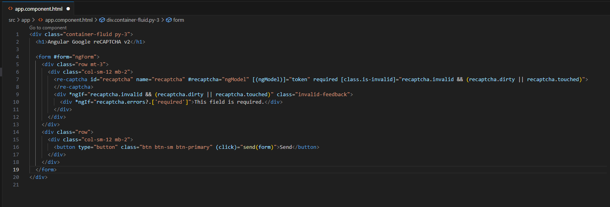

Step 8. Run the application with the command below.

* ng serve

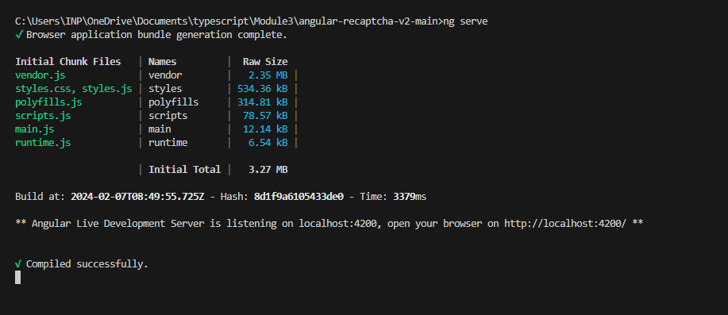

Step 9. Ready! Access the URL http://localhost:4200/ and check if the application is working.

* <http://localhost:4200/> click on this link

Output

